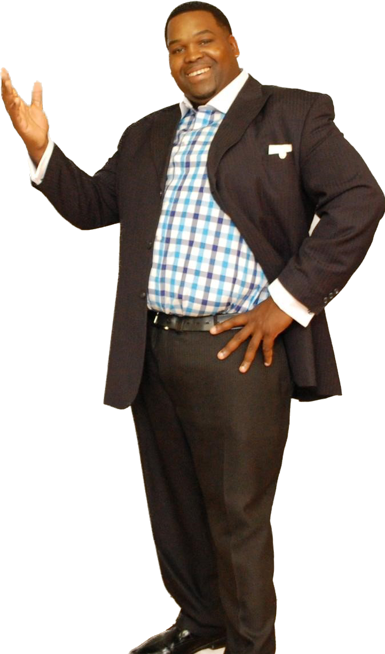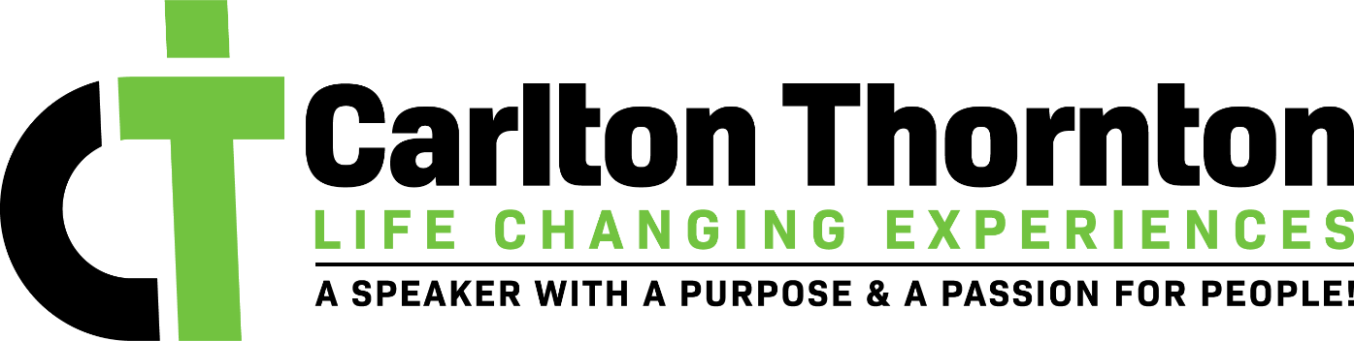

Carlton is a highly sought-after professional speaker who has addressed audiences of all sizes,

from preschoolers to corporate leaders and business executives, for over 20 years. Traveling

both locally and internationally, he brings to the table a wealth of insight, ideas, and practical principles

from his own life in leading a church, a trucking company, and a non-profit organization. Carlton

is a father of three handsome boys, a husband of over thirty years and a highly successful

entrepreneur and business owner. Carlton wears a coat of many colors, but it all centers

around empowering, equipping, and educating people to **SHIFT** into the best version of themselves.

**SHIFT = S**HIFTING **H**OW **I**NDUSTRIES **F**UNCTION **T**ODAY

Carlton holds an associate degree in Psychology from Baton Rouge Community College, a Bachelor

of Divinity degree from Faith University in Orlando, Florida, and a master’s degree from Slidell

Baptist Seminary in Slidell, Louisiana. In 2009, he won second place in a world champion speaking

competition, hosted by Toastmasters International. Carlton’s educational background and

skill set have afforded him the opportunity to reach and teach people to **SHIFT** their attitudes

and behaviors, in order to become more productive and proactive, and to perform with passion for the

people they serve.

It’s Carlton’s philosophy that any group, business, or organization can elevate, excel, and expand

beyond their natural abilities, if they are willing to **SHIFT** the way they think, act, and interact,

in order to make a greater impact in life, work, and relationships. His goal is to **SHIFT** the

gap between leaders and employees, in order to build a bridge between them and the

people they serve, so that they may connect, collaborate, and celebrate together.